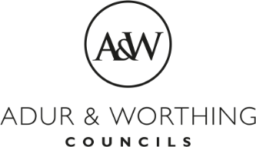  Revenues & Benefits | Adur & Worthing Councils,  Portland House,  44 Richmond Road,  Worthing,  West Sussex, BN11 1HS  www.adur-worthing.gov.uk

COUNCIL TAX REFUND APPLICATION FORM

Property Address:
Council Tax Account Number:
Council Tax Account Holders:

Our records show that this account is in credit with a refund due. In order to process this overpayment, a BACS refund will need to be issued in joint names. As such please provide your bank account details in the space provided below:

Bank Name:
Sort Code:
Account Number:
Account Holder/s:

If you do not hold a joint bank account, it will be necessary for the refund to be issued in one name only, and authorisation to this arrangement is required from all the named Council Tax payers.

The person nominated to receive the Council Tax refund is:

Name:
Address:

If possible, the other named Council Tax payers should sign their agreement to this arrangement below. You need to be aware that if any of the account holders approaches us regarding the refund we will confirm that it has been processed as above. This then becomes a private matter to be dealt with between you.

I/WE, THE UNDERSIGNED, CONFIRM THAT IT WILL BE IN ORDER FOR THE OVERPAYMENT OF COUNCIL TAX TO BE REFUNDED TO THE PERSON NAMED ABOVE.

Data Protection: I/we confirm that the information given above is true and complete. I/we understand that the data entered on this form will be entered into a database and used to maintain records for Council Tax and Non-Domestic Rates and may also be cross-checked against Housing Benefit records.

All Council Tax payers must sign the agreement, so please add all details below and continue overleaf if necessary.

Name/s:
Address/s:
Signature/s:
Dated:

